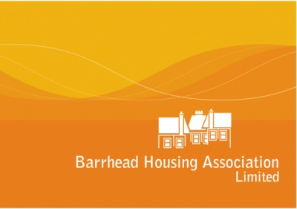

Barrhead Housing Association Limited
Governing Board
(Meets Monthly)

Policy and Monitoring Sub-Committee and  Audit Sub-Committee  (Meets quarterly) | Development sub-group and Staff Sub-group  (Meets as required) | Levern Property Services, subsidiary Board  (Meets quarterly) | Health & Safety Working Group  (Meets 6-monthly)

Senior Staff Team:
Shirley Robison, Chief Executive
Lorraine Dallas, Director of Customer Services
James Ward, Director of Asset Management
Helen Sutherland, Director of Corporate Services

