Barrhead Housing Association

Tenant Satisfaction Survey

August 2016

Prepared by: | Prepared for:
Research Resource  17b Main Street  Cambuslang  G72 7EX | Barrhead Housing Association  60 - 70 Main Street  Barrhead  Glasgow  G78 1SB
Contact: Lorna Shaw | Contact: Shirley Robison
Email: lorna.shaw@researchresource.co.uk | E-mail: shirleyr@barrheadha.org

Report written by: Gemma Eaton

Date: 18/08/2016

Reviewed by: Elaine MacKinnon/ Lorna Shaw
Date: 18/08/2016

Barrhead Housing Association
Customer Satisfaction Survey 2015/16
Contents

1. EXECUTIVE SUMMARY 5

2. INTRODUCTION, BACKGROUND AND OBJECTIVES 9
2.1 Introduction 9
2.2 Background and objectives 9

3. METHODOLOGY 10
3.1 Research Method 10
3.2 Questionnaire design 10
3.3 Sample Size 10
3.4 Interviewing and Quality Control 13
3.5 Survey Analysis and Reporting 13
3.6 Report Structure 13

4. OVERALL SATISFACTION 14
4.1 Satisfaction with the overall service provided by Barrhead HA (Q1) 14

5. COMMUNICATION AND PARTICIPATION 15
5.1 Keeping tenants informed (Q3) 15
5.2 Methods of communication (Q5) 16
5.3 Internet access (Q6) 17
5.4 Awareness of opportunities to participate (Q7) 18
5.5 Satisfaction with participation opportunities (Q8) 19

6. REPAIRS AND HOUSING QUALITY 20
6.1 Satisfaction with the repairs service (Q10-12) 20
6.2 Quality of the home (Q13) 21

7. NEIGHBOURHOOD MANAGEMENT 22
7.1 Satisfaction with estate services (Q16) 22
7.2 Satisfaction with the management of the neighbourhood (Q18) 23

8. RENT, INCOME AND AFFORDABILITY 24
8.1 Income maximisation services (Q20) 24
8.2 Housing benefit (Q20) / Affordability of rent payments (Q21) 25
8.3 Paying for fuel bills (Q22/23) 26
8.4 Understanding Rent Payments (Q24/25) 27
8.5 Value for money (Q26) 28

9. YOU AND YOUR HOUSEHOLD 29
9.1 Age and Gender (Q28/29) 29
9.2 Household composition (Q30/31) 29
9.3 Occupational Status (Q31) 30
9.4 Disability (Q32) 31
9.5 Ethnicity (Q33) 31

APPENDIX 1: QUESTIONNAIRE
APPENDIX 2: TECHNICAL REPORT SUMMARY

EXECUTIVE SUMMARY

INTRODUCTION
- Barrhead Housing Association commissioned Research Resource to carry out a customer satisfaction survey on their behalf.
- A total of 349 face to face interviews were carried out with Barrhead Housing Association’s tenants in order to assess satisfaction with the Association and the services it provides. Interviews took place between the 27th June 2016 and the 22nd July 2016. 349 interviews provides data accurate to +/-3.96%.
- Analysis of the participant profile shows that the survey sample is broadly representative by house size, house type and geography. This provides robust data upon which the Association can be confident about making decisions.
- This executive summary highlights the key findings from this programme of research.

OVERALL SATISFACTION
The table below shows the results for the Scottish Housing Regulator indicators for Barrhead Housing Association, compared to the Association’s previous tenant satisfaction survey, undertaken in 2014. As shown below, all indicators have seen an increase or remained consistent since the 2014 survey, with the exception of satisfaction with the repairs and maintenance service which has seen a decrease in satisfaction, decreasing from 93% in 2014 to 82% in 2016.
Scottish Housing Regulator indicators (Tenants only)
 | 2011 | 2014 | 2016
Q1 Taking everything into account, how satisfied or dissatisfied are you with the overall service provided by Barrhead Housing Association? (% very/ fairly satisfied) NB Quality of services in 2011 | 97% | 95% | 94%
Q5 How good or poor do you feel Barrhead is at keeping you informed about their services and decisions? (%very good/ fairly good) | 100% | 99% | 99%
Q14 How satisfied or dissatisfied are you with the opportunities given to you to participate in Barrhead’s decision making process? (% very/ fairly satisfied) (2011 figure excluded don’t know responses) | 98% | 59% | 96%
Q29 Thinking about the LAST time you had repairs carried out, how satisfied or dissatisfied were you with the repairs and maintenance service provided by Barrhead? (% very/ fairly satisfied)- Those who have reported a repair in the last 12 months (2011 figure is based on all tenants) | 94% | 93% | 82%
Q35 Overall, how satisfied or dissatisfied are you with the quality of your home? (% very/ fairly satisfied) | - | 91% | 92%
Q3 [IF LIVED IN THEIR PROPERTY FOR LESS THAN 12 MONTHS] Thinking about when you moved in, how satisfied or dissatisfied are you with the standard of your home? (% very/ fairly satisfied) | - | 82% | -
Q37 Taking into account the accommodation and services Barrhead provides, to what extent do you think that the rent for this property represents good or poor value for money? Is it… (% very good value/ fairly good value) | 46% | 51% | 94%
Q45 Overall, how satisfied or dissatisfied are you with Barrhead’s management of the neighbourhood you live in? | - | 79% | 91%

AREAS OF HIGH PERFORMANCE
The results of the 2016 survey reveal that, in general, the Association is performing to a high standard. The following points show the key highlights where satisfaction was highest:
- Overall satisfaction with the Association was high with more than 9 in 10 tenants (94%) stating they were very or fairly satisfied in this respect.
- Almost all respondents were of the opinion that Barrhead is very or fairly good at keeping them informed (99%).
- The vast majority of respondents were aware of way that they could become involved in Barrhead’s decision making processes (93%).
- Almost all respondents (96%) were very or fairly satisfied with the opportunities given to them to participate in their landlord’s decision making processes. The proportion of respondents very or fairly satisfied with the opportunities given to them to participate in their landlord’s decision making processes has increased from 59% in 2014 to 96% in 2016.
- Just over 9 in 10 respondents were very or fairly satisfied with the quality of their home (92%).
- More than 9 in 10 respondents (91%) were very or fairly satisfied with their landlord’s management of the neighbourhood that they live in.
- In terms of understanding rent payments, 89% of respondents said they understood how the rent they pay is set and 90% of respondents were of the opinion that they have enough information about how their rent is spent.
- 94% of respondents were of the opinion that their rent represented very or fairly good value for money.

ACTION PLANNING
The following points have been made to highlight key areas where there is room for improvement in terms of the Association’s current service offering. This includes indicators which have seen a decrease in satisfaction since the 2014 survey:
- Satisfaction with the repairs and maintenance service has decreased since the 2014 survey, decreasing from 93% in 2014 to 82% in 2016. The majority of respondents who said they were dissatisfied with the repairs service were dissatisfied as a result of their boilers not been fixed first time or continually breaking down.
- The Association should provide tenants with updates regarding their major repairs service as tenants who were not satisfied with the quality of their home, put this down to their home requiring major works or where major works have been promised but not yet completed.
- The Association has the opportunity to raise awareness of public access points such as the Library at the Foundry for those who don’t have internet access. Currently only 2 respondents said they used the service.
- In terms of neighbourhood service, the Association has the opportunity to make themselves more of a visual presence when it comes to services such as close cleaning.
- Awareness of the services Barrhead provide to ensure tenants are maximising their income and that living in a Barrhead property is affordable was low in relation to Access to Our Power, a new energy supply company for Housing Associations (5%). There is therefore potential to raise awareness of these services.
- Although the proportion of respondents stating they find it very or fairly easy to afford their rent payments has increased since the 2014 survey, it still remains low at 62%.
- Similar to rent payments, the proportion of tenants stating they find it very or fairly easy to afford their fuel bills has increased significantly since the 2014 survey, it still remains low at 49%.

INTRODUCTION, BACKGROUND AND OBJECTIVES

Introduction
This report represents and discusses the findings to emerge from Barrhead Housing Association’s Customer Satisfaction Survey 2015/16.

Background and objectives
The aim of the research was to seek customers’ views on the services that Barrhead provides and how well it performs these services and to help identify areas where the service can be improved. Specifically the research was designed to provide customers views on the following:
- The quality of information provided by Barrhead;
- Feedback on customer care;
- Quality of accommodation and the neighbourhood;
- Service provision including repairs, maintenance and improvements;
- Tenant involvement/ opportunities for participation;
- Value for money.
It is against this background that Research Resource were commissioned to carry out Barrhead’s 2016 Customer Satisfaction Survey.

METHODOLOGY

Research Method
We note that the Ipsos MORI guidance prepared on behalf of the Regulator debates the use of a range of different methodologies for carrying out the survey, including postal, online, telephone and face to face survey methods. However, given the requirement for a minimum of a 40% response rate and ensuring representative samples of tenants, it was decided that the tenant survey was carried out utilising a face to face survey methodology. The face to face methodology is the methodology, which is most typically used for tenant satisfaction surveys. Our primary reasons for recommending this were:
- Administering the survey utilising an interviewer led methodology allows us to maximise the response rate.
- The proposed methodology is an inclusive methodology and allows interviewers to ensure that, for example, elderly or those with a disability or literacy problems can be included in the process. It also lets us identify any potential barriers to participation which can be raised and addressed in partnership with the Association.
- Facilitates high quality of survey output as it allows the interviewer to build up a rapport with the participant ensuring that the questionnaire is answered in full and allowing explanation of the necessity for asking personal data.

Questionnaire design
After consultation with Barrhead Housing Association’s representatives, a survey questionnaire was agreed which fully met the information needs and requirements of the organisation and included all issues of importance for tenants.
In developing the questionnaire the following issues were considered:
- The information needs listed in the survey brief;
- The Scottish Social Housing Charter indicators upon which Barrhead is required to report;
- Comparisons to the previous survey undertaken in 2014;
- Research Resource experience in relation to customer satisfaction surveying.

Sample Size
The aim of the survey was to achieve a robust level of data upon which the Association can have confidence making decisions upon.
Overall, a total of 349 interviews were completed with Barrhead tenants, representing a 43% response rate and providing data accurate to +3.96% based upon a 50% estimate at the 95% confidence level. Tenant interviews were spread across each area of the Association’s stock to ensure coverage of all stock types.
The guidance from the Scottish Housing Regulator states that in all surveys, particularly postal surveys, some groups are more likely than others to respond. This means that certain subgroups will be under-represented and others will be over-represented in the final achieved sample (i.e. all the people who responded). Weighting ensures that received responses are representative of the whole survey population. The guidance suggests that social landlords will be likely to have suitable information on the population in terms of dwelling type (flats, semi-detached house, detached, terraces) and the number of bedrooms.
The tables below show the sample profile broken down by street and by area. As can be seen below, the interview profile is relatively in line with the overall tenant population profile in terms of street and area with the achieved sample, varying by no more than 3% points in terms of area. Despite this we are comfortable that the coverage of the tenant population is sufficiently close that weighting of survey data is not required. The data reported is therefore unweighted.
Address line 3 | No of population | % of population | No of interviews | % of interviews | Difference
Addison Grove | 1 | 0.1% | 0 | 0.0% | -0.1%
Auchenback Court | 8 | 1.0% | 4 | 1.1% | 0.2%
Aurs Drive | 2 | 0.2% | 1 | 0.3% | 0.0%
Aurs Glen | 1 | 0.1% | 0 | 0.0% | -0.1%
Aurs Road | 1 | 0.1% | 0 | 0.0% | -0.1%
Barnes Street | 44 | 5.4% | 21 | 6.0% | 0.6%
Bellfield Crescent | 1 | 0.1% | 0 | 0.0% | -0.1%
Braeside Crescent | 12 | 1.5% | 5 | 1.4% | 0.0%
Braeside Drive | 11 | 1.3% | 5 | 1.4% | 0.1%
Calder Avenue | 5 | 0.6% | 2 | 0.6% | 0.0%
Campbell Drive | 1 | 0.1% | 0 | 0.0% | -0.1%
Carlibar Road | 5 | 0.6% | 2 | 0.6% | 0.0%
Centenary Court | 25 | 3.1% | 11 | 3.2% | 0.1%
Centre Way | 24 | 2.9% | 11 | 3.2% | 0.2%
Clark Place | 1 | 0.1% | 0 | 0.0% | -0.1%
Clyde Avenue | 2 | 0.2% | 1 | 0.3% | 0.0%
Cogan Street | 7 | 0.9% | 3 | 0.9% | 0.0%
Commore Place | 2 | 0.2% | 1 | 0.3% | 0.0%
Connor Road | 7 | 0.9% | 3 | 0.9% | 0.0%
Craighead Street | 4 | 0.5% | 2 | 0.6% | 0.1%
Craigton Drive | 3 | 0.4% | 1 | 0.3% | -0.1%
Crebar Drive | 4 | 0.5% | 2 | 0.6% | 0.1%
Cross Arthurlie St | 28 | 3.4% | 13 | 3.7% | 0.3%
Crossmill Avenue | 32 | 3.9% | 14 | 4.0% | 0.1%
Culzean Crescent | 2 | 0.2% | 1 | 0.3% | 0.0%
Divernia Way | 18 | 2.2% | 8 | 2.3% | 0.1%
Eastwood Court | 3 | 0.4% | 1 | 0.3% | -0.1%
Elizabeth Crescent | 6 | 0.7% | 3 | 0.9% | 0.1%
Fenwick Drive | 20 | 2.5% | 9 | 2.6% | 0.1%
Fingleton Avenue | 1 | 0.1% | 0 | 0.0% | -0.1%
Gemmell Place | 1 | 0.1% | 0 | 0.0% | -0.1%
George Street | 49 | 6.0% | 12 | 3.4% | -2.6%
Gladstone Avenue | 22 | 2.7% | 10 | 2.9% | 0.2%
Glasgow Road | 1 | 0.1% | 0 | 0.0% | -0.1%
Harelaw Avenue | 12 | 1.5% | 5 | 1.4% | 0.0%
Henry Street | 23 | 2.8% | 9 | 2.6% | -0.2%
Hutcheson Road | 1 | 0.1% | 0 | 0.0% | -0.1%
Inglestone Avenue | 2 | 0.2% | 1 | 0.3% | 0.0%
John Street | 11 | 1.3% | 6 | 1.7% | 0.4%
Kelvin Drive | 1 | 0.1% | 0 | 0.0% | -0.1%
Killoch Drive | 3 | 0.4% | 1 | 0.3% | -0.1%
Kingston Avenue | 1 | 0.1% | 0 | 0.0% | -0.1%
Langton Crescent | 9 | 1.1% | 4 | 1.1% | 0.0%
Lochiel Road | 1 | 0.1% | 0 | 0.0% | -0.1%
Lowndes Court | 22 | 2.7% | 11 | 3.2% | 0.5%
Main Street | 39 | 4.8% | 18 | 5.2% | 0.4%
McCulloch Way | 24 | 2.9% | 11 | 3.2% | 0.2%
McKay Place | 1 | 0.1% | 0 | 0.0% | -0.1%
Mill Road | 2 | 0.2% | 1 | 0.3% | 0.0%
Moorhill Crescent | 4 | 0.5% | 2 | 0.6% | 0.1%
Moorhill Road | 1 | 0.1% | 0 | 0.0% | -0.1%
Netherplace Crescent | 1 | 0.1% | 0 | 0.0% | -0.1%
Newton Avenue | 32 | 3.9% | 15 | 4.3% | 0.4%
North Park Avenue | 11 | 1.3% | 5 | 1.4% | 0.1%
Rankin Court | 14 | 1.7% | 6 | 1.7% | 0.0%
Rankin Way | 37 | 4.5% | 17 | 4.9% | 0.3%
Ritchie Place | 1 | 0.1% | 0 | 0.0% | -0.1%
Robertson Street | 12 | 1.5% | 5 | 1.4% | 0.0%
Robslee Road | 1 | 0.1% | 0 | 0.0% | -0.1%
Rockmount Avenue | 2 | 0.2% | 1 | 0.3% | 0.0%
Roebank Drive | 6 | 0.7% | 3 | 0.9% | 0.1%
Saunders Court | 32 | 3.9% | 15 | 4.3% | 0.4%
Shanks Avenue | 1 | 0.1% | 0 | 0.0% | -0.1%
Simpson Gardens | 29 | 3.6% | 13 | 3.7% | 0.2%
South Park Avenue | 30 | 3.7% | 14 | 4.0% | 0.3%
Springfield Drive | 1 | 0.1% | 0 | 0.0% | -0.1%
Station Road | 2 | 0.2% | 1 | 0.3% | 0.0%
Stewart Court | 1 | 0.1% | 0 | 0.0% | -0.1%
Stewart Place | 7 | 0.9% | 3 | 0.9% | 0.0%
Stewart Street | 38 | 4.7% | 17 | 4.9% | 0.2%
Tait Avenue | 1 | 0.1% | 0 | 0.0% | -0.1%
Tower Avenue | 1 | 0.1% | 0 | 0.0% | -0.1%
Walton Street | 10 | 1.2% | 5 | 1.4% | 0.2%
Waulkmill Avenue | 20 | 2.5% | 9 | 2.6% | 0.1%
Waulkmill Way | 8 | 1.0% | 3 | 0.9% | -0.1%
Weir Avenue | 2 | 0.2% | 1 | 0.3% | 0.0%
Westfield Road | 1 | 0.1% | 0 | 0.0% | -0.1%
William Mann Drive | 1 | 0.1% | 0 | 0.0% | -0.1%
Wilson Place | 1 | 0.1% | 0 | 0.0% | -0.1%
Woodfarm Road | 2 | 0.2% | 1 | 0.3% | 0.0%
Total | 816 | 100.0% | 349 | 100.0% | 0.0%

Area | No of population | % of population | No of interviews | % of interviews | Difference
Barrhead | 734 | 90.0% | 322 | 92.3% | 2.3%
Neilston | 42 | 5.1% | 18 | 5.2% | 0.0%
Newton Mearns | 14 | 1.7% | 3 | 0.9% | -0.9%
Thornliebank | 26 | 3.2% | 6 | 1.7% | -1.5%
Total | 816 | 100.0% | 349 | 100.0% | 0.0%

Interviewing and Quality Control
All face to face interviewing was undertaken by Research Resource’s highly trained field force, all of whom are highly experienced in undertaking customer satisfaction surveys for Housing Associations and Local Authorities. Interviewing took place between the 27th June 2016 and the 22nd July 2016.

Survey Analysis and Reporting
Survey data has been analysed and reported on in a number of ways. Data has been analysed by key variables as agreed by the organisation. Where any particular trends or issues are found for any one key group, this is detailed in the survey report. Comparison has also been made with the Association’s 2014 Tenant Satisfaction Survey.

Report Structure
This document details the key finding to emerge from the survey for Barrhead Housing Association.

CHAPTER 4. OVERALL SATISFACTION
CHAPTER 5. COMMUNICATION AND PARTICIPATION
CHAPTER 6. REPAIRS AND HOUSING QUALITY
CHAPTER 7. NEIGHBOURHOOD QUALITY
CHAPTER 8. RENT, INCOME AND AFFORDABILITY
CHAPTER 9. YOU AND YOUR HOUSEHOLD

APPENDIX 1: QUESTIONNAIRE
APPENDIX 2: TECHNICAL REPORT SUMMARY

OVERALL SATISFACTION

Satisfaction with the overall service provided by Barrhead HA (Q1)
The survey opened by asking tenants how satisfied or dissatisfied they were with the overall service provided by their landlord. More than 9 in 10 tenants (94%) said they were very or fairly satisfied with the overall service the Association provides compared to 3% who were neither satisfied nor dissatisfied and 3% who were very or fairly dissatisfied amounting to 10 individuals. Overall satisfaction with the service provided by Barrhead Housing Association has remained consistent with the 2014 survey.
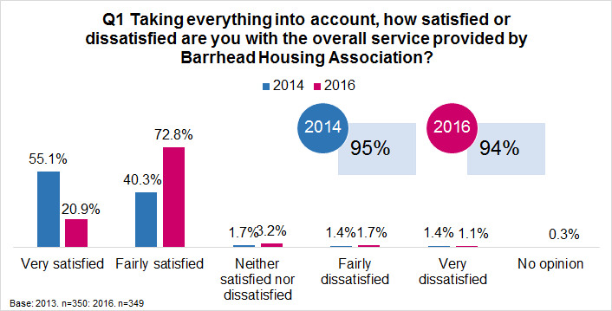

COMMUNICATION AND PARTICIPATION

Keeping tenants informed (Q3)
Almost all respondents were of the opinion that their landlord was very or fairly good at keeping them informed about their services and decisions (99%) compared to 1% who felt they were very poor. The proportion of respondents of the opinion that Barrhead is very or fairly good at keeping them informed has remained consistent with the 2014 survey.
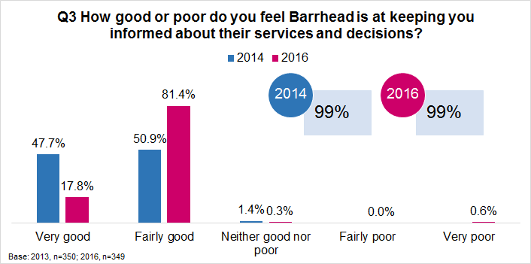
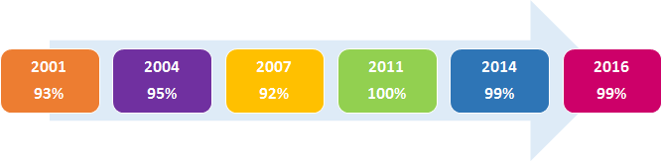

Methods of communication (Q5)
Following on from this respondents were then asked if they used any of the following methods of communication. The methods of communication that respondents used the most were, text messaging (75%), Email (56%) and Facebook (54%). Just under 1 in 4 respondents said they did not use any of these methods (24%).
Q5 Do you use any of the following?
Base: All respondents, n=349 | No. | %
Text messaging | 261 | 74.8%
Email | 196 | 56.2%
Facebook (inc Barrhead HA's Facebook) | 189 | 54.2%
Apps on your phone | 103 | 29.5%
Barrhead HA website | 47 | 13.5%
Twitter (inc Barrhead HA's twitter) | 13 | 3.7%
None of these | 82 | 23.5%

Perhaps unsurprisingly, analysis by age reveals that younger respondents (16-34) were more likely to use these methods of communication (99%) than respondents aged 65 and over (26%).
Q5 Do you use any of the following?
Base | 16-34 | 35-64 | 65 and over
 | 95 | 168 | 86
Facebook (inc Barrhead HA's Facebook) | 92% | 58% | 6%
Twitter (inc Barrhead HA's twitter) | 10% | 2% | -
Email | 82% | 64% | 13%
Text messaging | 100% | 88% | 21%
Apps on your phone | 60% | 27% | -
Barrhead HA website | 19% | 17% | 1%
None of these | 1% | 10% | 74%

Internet access (Q6)
Just over 6 in 10 respondents (63%) said they had internet access, with 54% stating they had mobile access through their smartphone or another mobile device and 44% of respondents stating they accessed the internet through broadband internet using a tablet at home.
Q6 Do you have access to, and use, the internet through any of the following?
Base: All respondents, n=349 | No. | %
Mobile internet access through smartphone/ mobile phone | 188 | 53.9%
Broadband internet access at home using a tablet | 153 | 43.8%
Broadband internet access at home using a notebook/ netbook/ laptop | 67 | 19.2%
Broadband internet access at home using desktop computer | 34 | 9.7%
Mobile internet access through tablet | 6 | 1.7%
At public access point e.g. The Library at the Foundry/ Auchenback Community Resource Centre/ Voluntary Action's office | 2 | 0.6%
No internet access | 131 | 37.5%

Analysis by age reveals that as age increases the proportion of tenants with internet access decreases, for example from 93% of tenants aged 16-34 to 13% of tenants aged 65 and over.
Q6 Do you have access to, and use, the internet through any of the following?
Base | 16-34 | 35-64 | 65 and over
 | 95 | 168 | 86
Broadband internet access at home using desktop computer | 8% | 15% | 1%
Broadband internet access at home using a notebook/ netbook/ laptop | 22% | 26% | 4%
Broadband internet access at home using a tablet | 68% | 49% | 7%
Mobile internet access through smartphone/ mobile phone | 93% | 58% | 2%
Mobile internet access through tablet | 4% | 1% | -
At public access point e.g. The Library at the Foundry/ Auchenback Community Resource Centre/ Voluntary Action's office | - | 1% | -
No internet access | 7% | 29% | 87%

Analysis by area, revealed that respondents from Neilston were the most likely to have no internet access. Please note the small base numbers.
Q6 Do you have access to, and use, the internet through any of the following?
 | Neilston | Barrhead | Newton Mearns | Thornliebank
Base | 18 | 322 | 3 | 6
Broadband internet access at home using desktop computer | 22% | 9% | - | -
Broadband internet access at home using a notebook/ netbook/ laptop | 28% | 19% | - | 33%
Broadband internet access at home using a tablet | 39% | 43% | 67% | 83%
Mobile internet access through smartphone/ mobile phone | 39% | 54% | 67% | 83%
Mobile internet access through tablet | - | 2% | - | -
At public access point e.g. The Library at the Foundry/ Auchenback Community Resource Centre/ Voluntary Action's office | - | 1% | - | -
No internet access | 44% | 38% | 33% | 17%

Awareness of opportunities to participate (Q7)
Respondents were read out a list of participation opportunities that tenants can be involved in to help improve the services provided from their landlord, and were asked to name the activities they were aware of. Awareness was highest in terms of, becoming a member of the Association and attending the AGM (90%) and attending open events (89%). Overall 93% of respondents were aware of ways that they could get involved with Barrhead’s decision making processes.
Q7 Were you aware that you could get involved in Barrhead Housing Association's decision making processes in any of the following ways?
Base: All respondents, n=349 | No. | %
Becoming a member of the Association and attending our AGM | 313 | 89.7%
Attending our Open events, e.g. tea dance, focus groups, open meetings | 310 | 88.8%
Providing feedback on our Newsletters, Performance Report and regular surveys e.g. rent consultation, repairs, complaints, etc. | 131 | 37.5%
Joining our Governing Board meetings as a volunteer | 80 | 22.9%
Joining our Tenant Scrutiny Panel | 34 | 9.7%
None | 24 | 6.9%

Satisfaction with participation opportunities (Q8)
Following on from this respondents were then asked how satisfied or dissatisfied they were with the opportunities given to them to participate in Barrhead’s decision making processes. Almost all respondents (96%) were very or fairly satisfied in this respect. The remaining 15 respondents were neither satisfied nor dissatisfied. Compared to the previous survey the proportion of respondents very or fairly satisfied with the opportunities to participate has increased significantly increasing from 59% in 2014 to 96% in 2016.
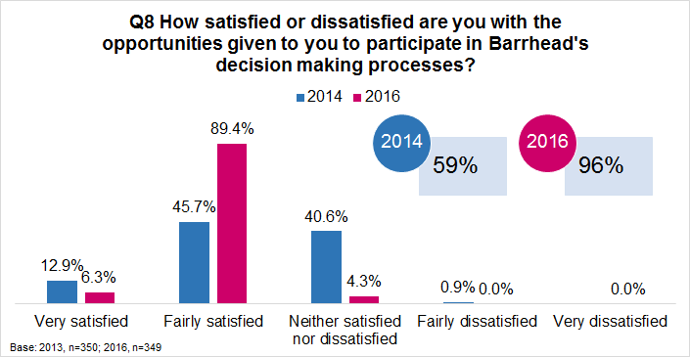
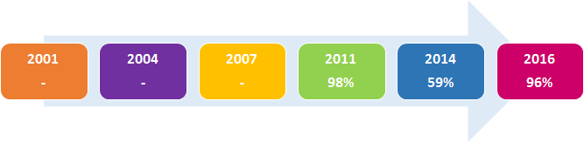

REPAIRS AND HOUSING QUALITY

Satisfaction with the repairs service (Q10-12)
4 in 10 respondents (40%) had a day to day repair carried out in their property within the last 12 months. Of these participants, the majority (76%) said they had a non-emergency repair carried out, 21% said it was a gas repair and 3% said their repair was an emergency.
Q11 Can you describe the nature of the LAST repair you had carried out?
Base: Respondents who had a repair carried out in the last 12 months, n=141 | No. | %
Gas repair for your boiler and heating | 29 | 20.6%
Emergency out of hours repair | 4 | 2.8%
Non-Emergency repair | 107 | 75.9%
Other | 1 | 0.7%

Thinking about the last repair they had carried out in their home, respondents who had a repair carried out in the last 12 months were then asked how satisfied or dissatisfied they were with the repairs and maintenance service provided by Barrhead. 82% of respondents were very or fairly satisfied in this respect, compared to 8% who were neither satisfied nor dissatisfied and 10% who were fairly dissatisfied with the service that they received. Compared to the 2014 survey the proportion of respondents very or fairly satisfied with the repairs and maintenance service has decreased significantly from 93% in 2014 to 82% in 2016.
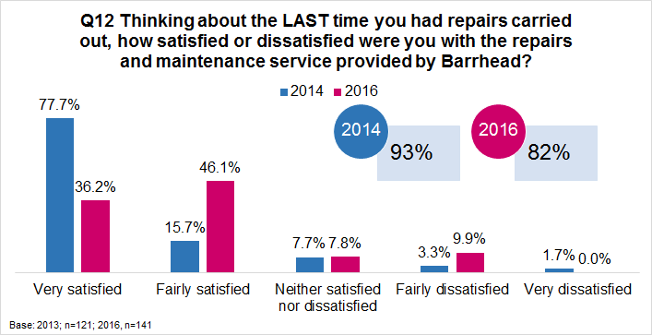

Analysis by area is displayed in the table below. Please note the small base numbers.
Q12 Thinking about the LAST time you had repairs carried out, how satisfied or dissatisfied were you with the repairs and maintenance service provided by Barrhead?
Base | Neilston | Barrhead | Newton Mearns | Thornliebank
 | 9 | 127 | 2 | 3
Very satisfied | 11% | 39% | 50% | -
Fairly satisfied | 67% | 44% | 50% | 67%
Neither satisfied nor dissatisfied | - | 9% | - | -
Fairly dissatisfied | 22% | 9% | - | 33%
Very dissatisfied | - | - | - | -

Analysis by repair type revealed that respondents who had non-emergency repairs carried out were more likely to be satisfied with the repairs and maintenance service provided than respondents who had a gas repair for their boiler or heating. Please note the small base numbers.
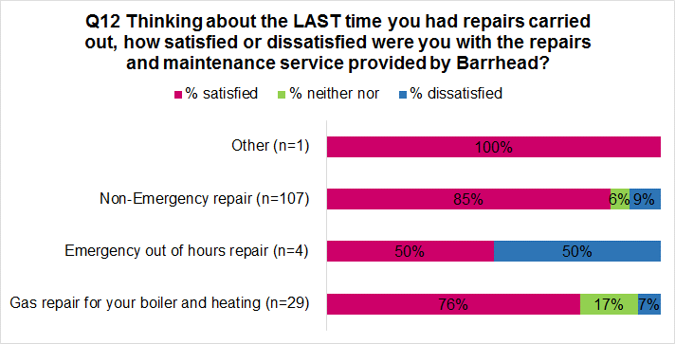

Quality of the home (Q14)
Just over 9 in 10 tenants (92%) were very or fairly satisfied with the quality of their home compared to 3% who were dissatisfied and 8% who were neither satisfied nor dissatisfied. Satisfaction with the quality of the home has remained consistent since the 2014 survey.
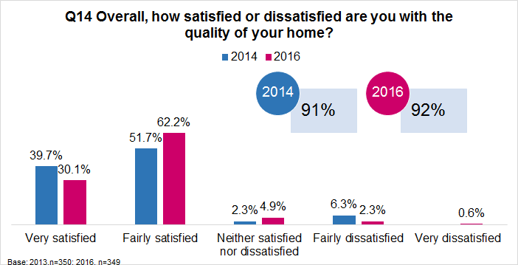

NEIGHBOURHOOD MANAGEMENT

Satisfaction with estate services (Q16)
Respondents were then asked how satisfied or dissatisfied they were with the various estate services provided by Barrhead in their neighbourhood. Satisfaction was highest in terms of,
- Cleaning of common closes (90% stating very or fairly satisfied)
- Grass cutting (85%)
- Arranging bulk uplifts (84%)
Please note that those who answered don’t know/ not applicable have been removed from the analysis. Although satisfaction is low for some services provided by Barrhead this may be due to these services not having a visual presence in neighbourhoods. Please note the small base numbers.
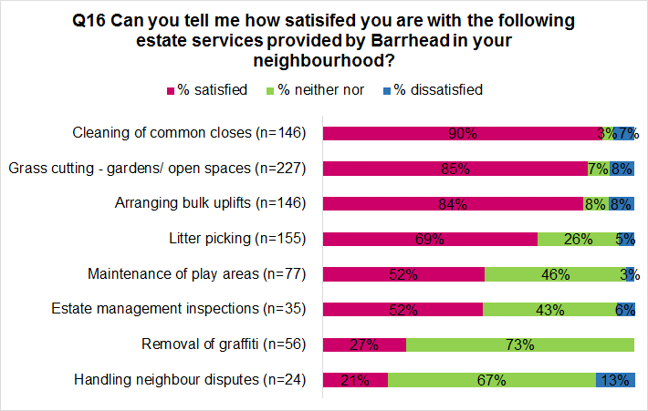

Satisfaction with the management of the neighbourhood (Q17)
Almost all respondents (91%) were either very or fairly satisfied with their landlord’s management of the neighbourhood, compared to 5% who were neither satisfied nor dissatisfied and 4% who were very or fairly dissatisfied. Satisfaction with the management of the neighbourhood has increased significantly since the previous survey increasing from 79% in 2014 to 91% in 2016.
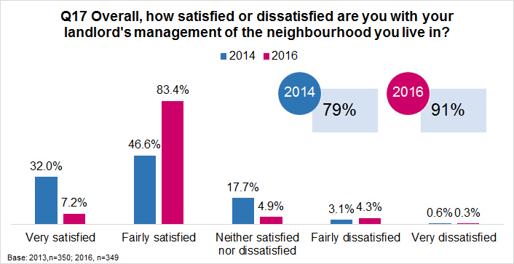

RENT, INCOME AND AFFORDABILITY

Income maximisation services (Q19)
Respondents were then asked if they were aware of the wide range of services Barrhead provide to ensure their tenants are maximising their income and that living in a Barrhead property is affordable. As can be seen in the chart below awareness ranged from 83% in terms of Welfare Benefits Advice to 5% in terms of Access to Our Power, a new energy supply company for Housing Associations.
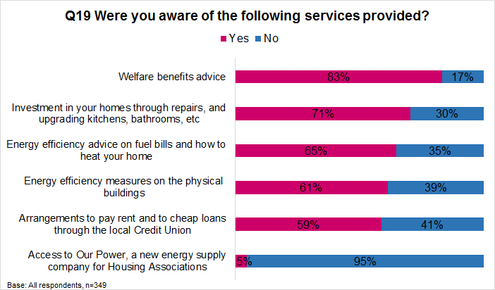

Housing benefit (Q20) / Affordability of rent payments (Q20/21)
62% of respondents were in receipt of full housing benefit, 5% in receipt of partial housing benefit and 33% stated that they do not receive any housing benefit.
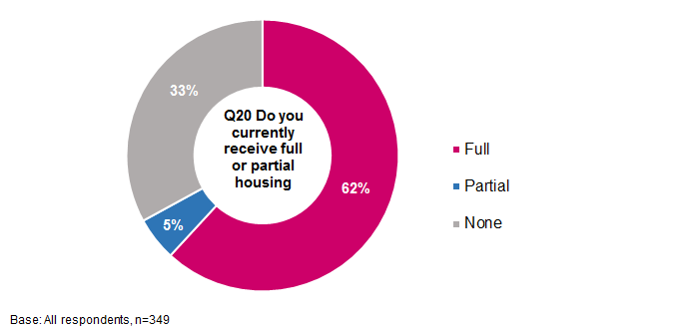

Those that make a rent payment, whether full or partial, were then asked how easy they find it to afford the rent payments for their home. As shown, 62% stated they find them easy to afford, 35% find them just about affordable and 3% stated that they find them difficult to afford. The proportion of tenants who said they find their rent payments easy to afford has increased significantly since the 2014 survey, increasing from 55% to 62%.
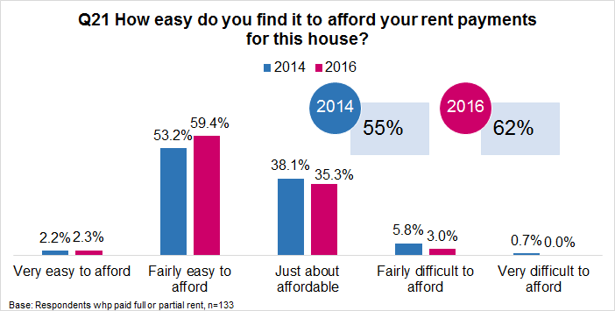

Paying for fuel bills (Q22/23)
Just under 6 in 10 respondents said they paid for their electricity and gas by a prepayment meter (58%), 34% said they paid by monthly direct debit and 7% of respondents said they paid their bills quarterly when their bill comes in.
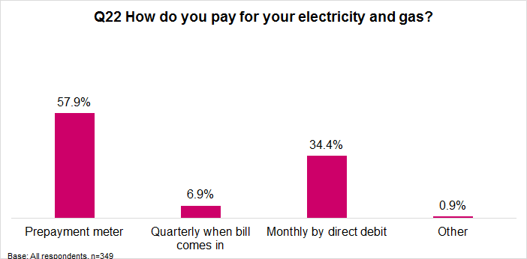

Just under half of respondents (49%) said they found it easy to afford their electricity and/or gas bills for their property, 50% stated that it was just about affordable and 2% stated that they found it difficult to afford. Similar to affording rent payments the proportion of respondents who felt their electricity and or gas bills easy to afford has increased significantly since the 2014 survey, increasing from 21% to 49%.
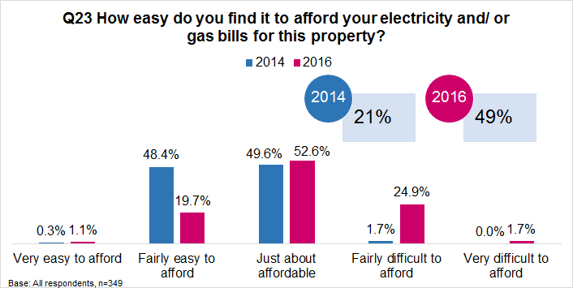

Understanding Rent Payments (Q24/25)
In terms of understanding how rent is set, just under 9 in 10 respondents (89%) said they understood how the rent they pay is set.
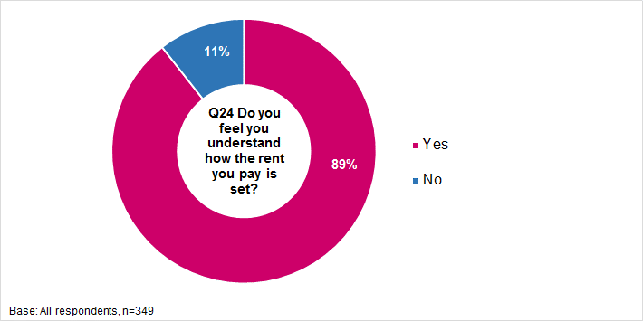
9 in 10 respondents were of the opinion that they have enough information about how the rent they pay is spent (90%).
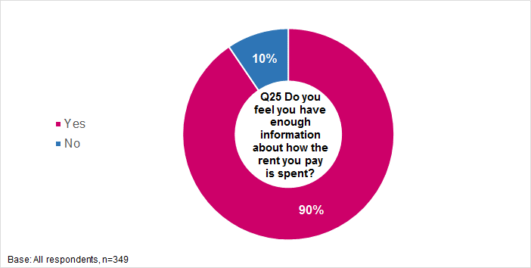

Value for money (Q26)
In terms of value for money, almost all respondents (94%) were of the opinion that their rent represents very or fairly good value for money, compared to 4% who felt it represents neither good nor poor value and 2% who felt it represents very or fairly poor value for money. Compared to the previous survey carried out in 2014, the proportion of respondents of the opinion that their rent represents very or fairly good value for money has increased significantly from 51% to 94%.
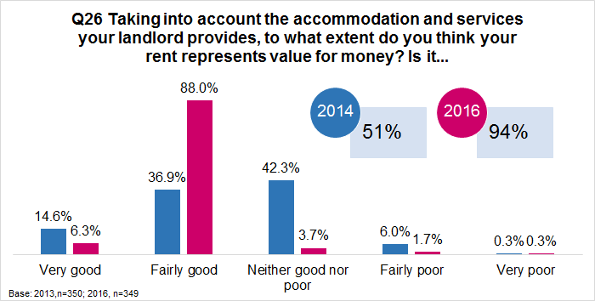
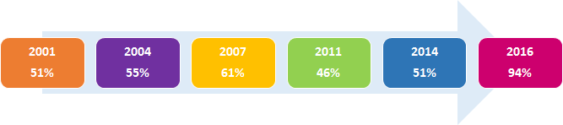

YOU AND YOUR HOUSEHOLD

Age and Gender (Q28/29)
69% of interviews were undertaken with females and 31% with males. In terms of the age profile of participants, 27% were aged 18 to 34, 17% were aged 35 to 44, 17% were aged 45 to 54, 14% were aged 55-64 and 25% were aged 65 and over.
Q28 What is your age?
Base: All respondents, n=349 | No. | %
16-24 | 8 | 2.3%
25-34 | 87 | 24.9%
35-44 | 59 | 16.9%
45-54 | 59 | 16.9%
55-64 | 50 | 14.3%
65 and over | 86 | 24.6%

Household composition (Q30/31)
In terms of household composition, just over 4 in 10 respondents (45%) were single adult households, 16% were two adult households with no children, 19% were lone parents with at least one child, 13% were couples with at least one child, and 5% were households with three or more adults.
Q31 How would you describe the composition of your household?
Base: All respondents, n=349 | No. | %
One adult aged 60 | 85 | 24.4%
One adult aged 60 or over | 70 | 20.1%
Two adults both under 60 | 25 | 7.2%
Two adults both over 60 | 18 | 5.2%
Two adults, at least one 60 or over | 13 | 3.7%
Three or more adults, 16 or over | 18 | 5.2%
1 parent family with 1 child under 16 | 26 | 7.4%
1 parent family with 2 children under 16 | 34 | 9.7%
1 parent family with 3 or more children under 16 | 6 | 1.7%
2 parent family with 1 child under 16 | 17 | 4.9%
2 parent family with 2 children under 16 | 17 | 4.9%
2 parent family with 3 or more children under 16 | 10 | 2.9%
Other | 10 | 2.9%

Analysis by area is displayed in the table below.
Q31 How would you describe the composition of your household?
Base | Neilston | Barrhead | Newton Mearns | Thornliebank
 | 18 | 322 | 3 | 6
One adult aged 60 | 22% | 25% | 33% | 17%
One adult aged 60 or over | 39% | 20% | - | -
Two adults both under 60 | 6% | 7% | - | 33%
Two adults both over 60 | 11% | 5% | - | -
Two adults, at least one 60 or over | 6% | 4% | - | -
Three or more adults, 16 or over | - | 5% | - | 17%
1 parent family with 1 child under 16 | - | 7% | 67% | 17%
1 parent family with 2 children under 16 | - | 11% | - | -
1 parent family with 3 or more children under 16 | - | 2% | - | 17%
2 parent family with 1 child under 16 | - | 5% | - | -
2 parent family with 2 children under 16 | 6% | 5% | - | -
2 parent family with 3 or more children under 16 | 11% | 3% | - | -
Other | - | 3% | - | -

Occupational Status (Q31)
The table below shows the working status for participants, 30% were in employment, 18% were looking after the family, 19% were long term sick or disabled, 6% were unemployed and 24% were retired
Q32 Which of the following best describes your occupational status?
Base: All respondents, n=349 | No. | %
Full time paid work (35 or more hours more week) | 70 | 20.1%
Part time paid work (less than 35 hours per week, more than 16 hours per week) | 34 | 9.7%
Part time paid work (less than 16 hours per week) | 1 | 0.3%
Full time education | 3 | 0.9%
Unemployed and seeking work | 21 | 6.0%
Unemployed and not seeking work | 1 | 0.3%
Long term sick/ disabled | 66 | 18.9%
Looking after family | 64 | 18.3%
Retired | 85 | 24.4%
Other | 4 | 1.1%

Disability (Q32)
Just under 4 in 10 respondents (38%) said that they or someone else in their household has a disability, long term illness or condition which has lasted or is expected to last at least 12 months.
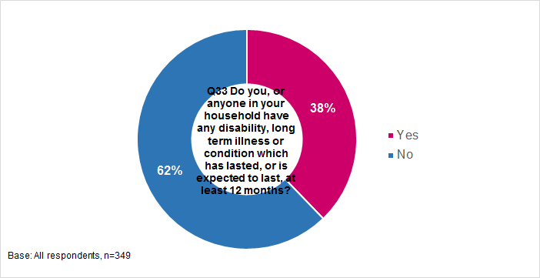

Ethnicity (Q33)
With regards to ethnicity, the vast majority of participants said they were White Scottish (94%) and 2% were Polish.
Q34 What is your ethnic group?
Base: All respondents, n=349 | No. | %
Scottish | 329 | 94.3%
Polish | 8 | 2.3%
Other white ethnic group | 4 | 1.1%
African, African Scottish or African British | 4 | 1.1%
Other British | 3 | 0.9%
Other group | 1 | 0.3%

Appendix 1
Survey Questionnaire

Project number | P827
Project name | Barrhead HA Tenant Satisfaction Survey 2016

Respondent name

Record in capitals
Address

Record in capitals
Postcode

Record in capitals

Telephone Number

[INTERVIEWER: CLOSE INTERVIEW BY READING OUT STATEMENT]
“Thank you very much for your help. Can I assure you once again that the information you have given will be treated as absolutely confidential and will only be used for the purposes of genuine market research.”
INTERVIEWER DECLARATION:
I declare that this interview was carried out according to instructions, within the Market Research Society’s Code of Conduct, and that the respondent was not previously known to me.
Interviewer No: |  | Name:
Questionnaire No |  | Signature:
On quota: |  | Date:
Edited by: |  | Duration
Backchecked by:
Overall satisfaction
- [SSHC1] Taking everything into account, how satisfied or dissatisfied are you with the overall service provided by Barrhead Housing Association?
Very satisfied | 1 | Go to Q3
Fairly satisfied | 2
Neither satisfied nor dissatisfied | 3 | Go to Q2
Fairly dissatisfied | 4
Very dissatisfied | 5
No opinion | 6 | Go to Q3

- You said you were not satisfied with the overall service provided by Barrhead Housing Association. Can you please explain why?

Communication and Participation
- [SSHC3] How good or poor do you feel Barrhead is at keeping you informed about their services and decisions?
Very good | 1 | Go to Q5
Fairly good | 2
Neither good nor poor | 3 | Go to Q4
Fairly poor | 4
Very poor | 5

- You said you do not believe that Barrhead are good at keeping you informed about their services and decisions. Can you please explain how they could improve how they keep you informed?

- Do you use any of the following? [INTERVIEWER READ OUT LIST TO THE END AND TICK ALL THAT APPLY]
Facebook (inc Barrhead HA’s Facebook) | 1 | Go to Q6
Twitter (inc Barrhead HA’s twitter) | 2
Email | 3
Text messaging | 4
Apps on your phone | 5
Barrhead HA website | 6
None of these | 7
Other method (please specify) | 8

- Do you have access to, and use, the Internet through any of the following? [INTERVIEWER READ OUT LIST TO THE END AND TICK ALL THAT APPLY]
Broadband internet access at home using desktop computer | 1 | Go to Q7
Broadband internet access at home using a notebook/ netbook/ laptop | 2
Broadband internet access at home using a tablet | 3
Mobile internet access through smartphone/ mobile phone | 4
Mobile internet access through tablet | 5
Internet access at home through games console | 6
Internet access at home through television | 7
At school (including college or uni) | 8
At public access point e.g. The Library at the Foundry/Auchenback Community Resource Centre /Voluntary Action’s office | 9
No internet access | 10
Other (please write in) | 11

- Were you aware that you could get involved in Barrhead Housing Association’s decision making processes in any of the following ways? READ OUT LIST AND SELECT ALL THAT APPLY.
Joining our Tenant Scrutiny Panel | 1 | Go to Q8
Attending our Open events, eg tea dance, focus groups, open meetings | 2
Providing feedback on our Newsletters, Performance Report and regular surveys eg rent consultation, repairs, complaints, etc | 3
Becoming a member of the Association and attending our AGM | 4
Joining our Governing Board meetings as a volunteer | 5
None | 6

- [SSHC6] How satisfied or dissatisfied are you with the opportunities given to you to participate in Barrhead’s decision making processes?
Very satisfied | 1 | Go to Q10
Fairly satisfied | 2
Neither satisfied nor dissatisfied | 3 | Go to Q9
Fairly dissatisfied | 4
Very dissatisfied | 5

- You said you were not satisfied with the opportunities provided by Barrhead to participate in their decision making processes. Can you please explain how they could improve the opportunities provided?

Repairs and Housing Quality
- [SSHC16] Have you had any repairs carried out on this property in the last 12 months?
Yes | 1 | Go to Q11
No | 2 | Go to Q14

- Can you describe the nature of the LAST repair you had carried out?
Gas repair for your boiler and heating | 1 | Go to Q12
Emergency out of hours repair | 2
Non-Emergency repair | 3
Other (please describe) | 4

- [SSHC16] Thinking about the LAST time you had repairs carried out, how satisfied or dissatisfied were you with the repairs and maintenance service provided by Barrhead?
Very satisfied | 1 | Go to Q14
Fairly satisfied | 2
Neither satisfied nor dissatisfied | 3 | Go to Q13
Fairly dissatisfied | 4
Very dissatisfied | 5

- You said you were not satisfied with the service provided by Barrhead the last time you had a repair carried out. Can you please explain how the service provided could be improved?

- [SSHC10] Overall, how satisfied or dissatisfied are you with the quality of your home?
Very satisfied | 1 | Go to Q16
Fairly satisfied | 2
Neither satisfied nor dissatisfied | 3 | Go to Q15
Fairly dissatisfied | 4
Very dissatisfied | 5

- You said you were not satisfied with the quality of your home. Can you please explain how this could be improved?

Neighbourhood Management
- SHOW CARD – Looking at this card, can you tell me how satisfied you are with the following estate services provided by Barrhead in your neighbourhood? [IF TENANTS DO NOT RECEIVE SERVICE E.G. COMMON CLOSE CLEANING CODE NOT APPLICABLE]
 | Very Satisfied | Fairly Satisfied | Neither / Nor | Fairly Dissatisfied | Very Dissatisfied | DK/ NA
Litter picking | 1 | 2 | 3 | 4 | 5 | 6
Cleaning of common closes | 1 | 2 | 3 | 4 | 5 | 6
Grass cutting –gardens/open spaces | 1 | 2 | 3 | 4 | 5 | 6
Removal of graffiti | 1 | 2 | 3 | 4 | 5 | 6
Maintenance of play areas | 1 | 2 | 3 | 4 | 4 | 6
Arranging bulk uplifts | 1 | 2 | 3 | 4 | 5 | 6
Estate management inspections | 1 | 2 | 3 | 4 | 5 | 6
Handling of neighbour disputes | 1 | 2 | 3 | 4 | 5 | 6

- [SSHC17] Overall, how satisfied or dissatisfied are you with your landlord’s management of the neighbourhood you live in? [INTERVIEWER NOTE: Neighbourhood is defined as the street in which the tenant lives and the immediate surrounding area.]
Very satisfied | 1 | Go to Q19
Fairly satisfied | 2
Neither satisfied nor dissatisfied | 3 | Go to Q18
Fairly dissatisfied | 4
Very dissatisfied | 5

- You said you were not satisfied with Barrhead’s management of the neighbourhood you live in. Can you please explain how this could be improved?

Rent, income and affordability
- Barrhead is concerned about how its tenants are managing financially these days. They therefore provide a range of services that help tenants maximise their income and help ensure that living in a Barrhead property is affordable. Were you aware of the following services provided?
 | Yes | No
Welfare benefits advice eg housing benefit, Universal Credit and personal benefits | 1 | 2
Arrangements to pay rent and to cheap loans through the local Credit Union | 1 | 2
Energy efficiency advice on fuel bills and how to heat your home | 1 | 2
Energy efficiency measures on the physical buildings eg insulation of walls/roofs | 1 | 2
Investment in your homes through repairs, and upgrading kitchens, bathrooms, etc | 1 | 2
Access to Our Power, a new energy supply company for housing associations | 1 | 2

- Do you currently receive full or partial housing benefit?
Full | 1 | Go to Q22
Partial | 2 | Go to Q21
None | 3

- How easy do you find it to afford your rent payments for this house?
Very easy to afford | 1
Fairly easy to afford | 2
Just about affordable | 3
Fairly difficult to afford | 4
Very difficult to afford | 5

- How do you pay for your electricity and gas?
Prepayment meter | 1
Quarterly when bill comes in | 2
Monthly by direct debit | 3
Other (specify) | 4

- How easy do you find it to afford your electricity and/or gas bills for this property?
Very easy to afford | 1
Fairly easy to afford | 2
Just about affordable | 3
Fairly difficult to afford | 4
Very difficult to afford | 5

- Do you feel you understand how the rent you pay is set?
Yes | 1
No | 2

- Do you feel you have enough information about how the rent you pay is spent?
Yes | 1
No | 2

- [SSHC29] Taking into account the accommodation and services your landlord provides, to what extent do you think your rent represents value for money? Is it…
Very good | 1 | Go to Q28
Fairly good | 2
Neither good nor poor | 3 | Go to Q27
Fairly poor | 4
Very poor | 5

- You said you do not believe that the rent you pay represents good value for money. Can you please explain why?

You and your household
- What is your age?

- Gender?
Male | 1
Female | 2

- How many people usually live in this house?

- SHOWCARD How would you describe the composition of your household?
One adult under 60 | 1
One adult aged 60 or over | 2
Two adults both under 60 | 3
Two adults both over 60 | 4
Two adults, at least one 60 or over | 5
Three or more adults, 16 or over | 6
1 parent family with 1 child under 16 | 7
1 parent family with 2 children under 16 | 8
1 parent family with 3 or more children under 16 | 9
2 parent family with 1 child under 16 | 10
2 parent family with 2 children under 16 | 11
2 parent family with 3 or more children under 16 | 12
Other (please specify) | 13

- SHOWCARD Which of the following best describes your occupational status? ONE ONLY
Full time paid work (35 or more hours more week) | 1
Part time paid work (less than 35 hours per week, more than 16 hours per week) | 2
Part time paid work (less than 16 hours per week) | 3
Full time education | 4
Government training programme | 5
Unemployed and seeking work | 6
Unemployed and not seeking work | 7
Long term sick / disabled | 8
Looking after family | 9
Retired | 10
Other (please specify) | 11

- Do you, or anyone in your household have any of the disability, long term illness or condition which has lasted, or is expected to last, at least 12 months? [CODE ALL THAT APPLY]
Yes | 1
No | 2

- What is your ethnic group?
WHITE
Scottish | 1
Other British | 2
Irish | 3
Gypsy/ Traveller | 4
Polish | 5
Other white ethnic group, please write in | 6
MIXED OR MULTIPLE ETHNIC GROUPS
Any mixed or multiple ethnic groups, please write in | 7
ASIAN, ASIAN SCOTTISH OR ASIAN BRITISH
Pakistani, Pakistani Scottish or Pakistani British | 8
Indian, Indian Scottish or Indian British | 9
Bangladeshi, Bangladeshi Scottish or Bangladeshi British | 10
Chinese, Chinese Scottish or Chinese British | 11
Other, please write in | 12
AFRICAN, CARIBBEAN OR BLACK
African, African Scottish or African British | 13
Caribbean, Caribbean Scottish or Caribbean British | 14
Black, Black Scottish or Black British | 15
Other, please write in | 16
OTHER ETHNIC GROUP
Arab, Arab Scottish or Arab British | 17
Other group, please write in | 18

- Do you have any other comments you wish to make about the Association and its services? [INTERVIEWER: RECORD FULLY]

Thank and close statement
- Thank you very much for completing the questionnaire.
- Are you happy to sign the questionnaire to verify that you have taken part in the survey and your response has been recorded accurately?

‘I confirm that this interview has been conducted in a proper manner and that the interviewer has accurately recorded the information I have provided’.
Signature
Print name

THANK YOU AND CLOSE

Appendix 2
Technical Report Summary

TECHNICAL REPORT SHEET – QUANTITATIVE RESEARCH
Project number | P827
Project name | Barrhead Housing Association Tenant Satisfaction Survey 2016
Objectives of the research | The aim of the research was to seek customers’ views on the services that Barrhead provides, how well it performs these services and to help identify areas where the service can be improved. Specifically the research was designed to provide customers views on the following:  - The quality of information provided by Barrhead;  - Feedback on customer care;  - Quality of accommodation and the neighbourhood;  - Service provision including repairs, maintenance and improvements;  - Tenant involvement/ opportunities for participation;  - Value for money.
Target group | Barrhead Housing Association tenants.
Target sample size | The aim was to achieve a sufficient number of interviews to provide data accurate to +/- 5%.
Achieved sample size | A total of 349 tenant interviews were achieved.
Date of fieldwork | Interviewing took place between the 27th June and the 22nd July 2016.
Sampling method | Interviews spread across organisation stock.
Data collection method | Interviews were undertaken with the tenant or their partner on a face to face basis. All responses were recorded on a paper questionnaire and the data entered into a survey analysis package by a team of data processors.
Response rate and definition and method of how calculated | 43% (349 from a sample of 816)
Any incentives? | No
Number of interviewers | 5 interviewers were working on this.
Interview validation methods | 10% of each interviewers work was back checked to ensure that interviews have been completed accurately and in line with ISO 20252 standards.
Showcards or any other materials used? | Showcards used as per instructions on questionnaire
Weighting procedures | Not applicable
Estimating and imputation procedures | Not applicable
Reliability of findings | Data accurate overall to +/-3.96% for tenants.

