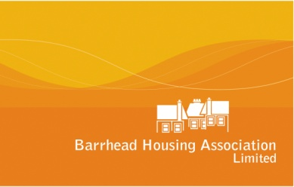

Policy on : | Customer Participation Strategy

Compliant with Regulatory Guidance/charter: | Charter indicator 1 Equalities  Charter indicator 2 Communication  Charter Indicator 3 Participation
Compliant with Tenant Participation Strategy : | Consultation Ongoing but not yet completed
Compliant with Equal Opportunities : | Yes
Compliant with Business Plan : | Yes

Date of Approval following consultation:  Date for Review : | June 2019  June 2022

Responsible Officer : | Director of Customer Services

CONTENTS

1. Introduction
2. Legislative Background
2.1 The Housing (Scotland) Act 2001
2.2 The Housing (Scotland) Act 2010
2.3 The Community Empowerment (Scotland) Act 2015
2.4 Registered Tenant Organisations (RTO)
2.5 The Freedom of Information (Scotland) Act 2002 and Environmental Information (Scotland) Regulations 2004
3. Scottish Social Housing Charter
3.1 Outcome 1: Equalities
3.2 Outcome 2: Communication
3.3 Outcome 3: Participation
3.4 The Scottish Housing Regulator
  - Assurance Statements
4. Aims and Objectives
5. Resources & Support
6. Participation Funding
7.1 Craft Café
7.2 Community Fund
7.3 Drop-in Consultation Events
7.4 Rent Consultation
7.5 Sheltered Complex Meetings
7.6 Tenant Satisfaction Surveys
7.7 Repairs Satisfaction Surveys
7.8 FLAIR Academy
7.9 Registered Tenant Organisations (RTO)
7.10 Other Information
8. Participation Standards
9. Communication Strategy
10. Participation and Consultation
11. Action Plan
12. Monitoring of the Strategy
13. Equality & Diversity
14. Strategy Review

Appendices:
- 5 Year Action Plan

1. Introduction
Tenant participation is at the heart of our approach to improving the quality of
services we deliver. We want to deliver excellent services that meet our tenant needs and provide value for money. We believe that the views our tenants can help us to provide a service that meets their needs.

Tenant participation is an important part of achieving this and our Tenant Participation Strategy has been developed to ensure that we provide our tenants with the opportunities to be involved in our decisions.
There are also legal requirements that social landlords need to meet in relation to tenant participation and this strategy has been set out to ensure that we can meet our legal obligations.
This is our fifth Tenant Participation Strategy, produced by Barrhead Housing Association in conjunction with tenants, tenants groups, elected members and other key stakeholders, and reflects Barrhead Housing Association’s commitment to meeting our statutory requirements and developing effective consultation and participation. By working in partnership with our tenants and customers we will continue to improve the development of housing and related services.
This strategy describes a series of actions that the Association intends to implement to support and enable tenant participation. It also highlights a range of activities that we have used since the last Strategy was implemented.
This Strategy:
- Details a series of objectives and actions for the period 2019-2024.
- Outlines the resources available to support participation.
- Sets out our priorities for tenant involvement for 2019-2024.
- Provides a focus for individual tenants, tenants groups, Registered Tenant Organisations (RTOs), Tenant Scrutiny Panel, residents and other community groups who wish to jointly work with Barrhead Housing Association to improve services.
- Shows how we will assess our progress and measure the impact of the strategy
Our Strategy also takes account of commitments surrounding tenant participation as outlined within our 5 year Business Plans’ strategic and operative objectives for 2019-2024.

We will maintain our engagement and participation with our customers in delivery of our services including maximising the opportunities to improve the health and well-being of our customers’ lives.

2 Legislative Background
2.1 The Housing (Scotland) Act 2001
This Act introduced a legal framework for tenant participation. The Act introduced new rights for tenants and placed new duties on landlords.

Social landlords are required to:
- provide a range of information for tenants
- have a Tenant Participation Strategy in place
- have a registration scheme for tenant organisations
- keep a publicly available register of these registered tenant organisations
- consult with tenants and registered tenant organisations on a range of housing and related services

2.2 The Housing (Scotland) Act 2010
This Act included provision for a Scottish Social Housing Charter; and set out what tenants and other customers can expect from social landlords.

2.3 The Community Empowerment (Scotland) Act 2015
This Act is indirectly relevant to this strategy and has specific focus on promoting effective engagement and participation to help communities achieve greater control and influence in the decisions and circumstances that affect their lives.

The Association work closely with East Renfrewshire Council to maximise participation on and engage in a range of subjects and activities which ensure compliance with this Act.

2.4 Registered Tenant Organisations (RTO)
The Housing (Scotland) Act 2001 introduced the idea of registered tenants’ organisations (RTOs). It means that any tenants’ group can apply to become an RTO.

2.5 The Freedom of Information (Scotland) Act 2002 and Environmental Information (Scotland) Regulations 2004
These Acts gives people the right to ask for, and be given, information from Scottish public bodies. From November 2019, this legislation extends to cover Housing Associations and subsidiary bodies including Barrhead Housing Association.
3. Scottish Social Housing Charter
The Charter was established to create an environment in which the Association and our customers must work in partnership. Landlords must deliver quality services, involving their customers in assessing the performance of these services and be able to demonstrate value for money. The Association is also required to produce and issue an Annual Performance Report and Value for Money Statement to all tenants.
The specific Charter Outcomes which all social landlords should aim to achieve when performing our housing activities, relate to:
3.1 Outcome 1: Equalities
Social landlords perform all aspects of their housing services so that:
• Every tenant and other customer has their individual needs
recognised, is treated fairly and with respect, and receives fair
access to housing and housing services.

This outcome describes what social landlords, by complying with equalities legislation, should achieve for all tenants and other customers regardless of age, disability, gender reassignment, marriage and civil partnership, race, religion or belief, sex, or sexual orientation.

It includes landlords’ responsibility for finding ways of understanding the rights and needs of different customers and delivering services that recognise and meet these.

3.2 Outcome 2: Communication
Social landlords manage their businesses so that:
• tenants and other customers find it easy to communicate with their
landlord and get the information they need about their landlord,
how and why it makes decisions and the services it provides.

This outcome covers all aspects of landlords’ communication with tenants and other customers. This could include making use of new technologies such as web-based tenancy management systems and smart-phone applications. It is not just about how clearly and effectively a landlord gives information to those who want it. It also covers making it easy for tenants and other customers to make complaints and provide feedback on services, using that information to improve services and performance, and letting people know what they have done in response to complaints and feedback. It does not require landlords to provide legally protected, personal or commercial information.

3.3 Outcome 3: Participation
Social landlords manage their businesses so that:

• Tenants and other customers find it easy to participate in and
influence their landlord’s decisions at a level they feel comfortable
with.

This outcome describes what landlords should achieve by meeting their
Statutory duties on tenant participation. It covers how social landlords gather and take account of the views and priorities of their tenants, other customers, and bodies representing them such as registered tenant organisations; how they shape their services to reflect these views; and how they help tenants, other customers and bodies representing them such as
registered tenant organisations to become more capable of involvement –
this could include supporting them to scrutinise landlord services.

3.4 The Scottish Housing Regulator
The Scottish Housing Regulator (SHR) was established in April 2011 under the Housing (Scotland) Act 2010; the SHR is the independent regulator of Registered Social Landlords RSL’s) and local authority housing services in Scotland. The regulator has one statutory objective, to:

‘safeguard and promote the interests of current and future tenants of social landlords, people who are or may become homeless, and people who use the housing services provided by registered social landlords (RSL’s) and local authorities’.

3.5 Assurance Statements
Social landlords are now required to submit an Annual Assurance Statement to the Scottish Housing Regulator. Barrhead Housing Association will therefore need to comply with the relevant requirements of chapter 3 of the Regulatory Framework, which relates to ensuring we meet all relevant legislative duties.

- Aims and Objectives
Our overall aim is to make sure that our tenants have real opportunities to become involved in the decision making process of Barrhead Housing Association.
Our specific main aims are to:
- Offer a range of options for tenants to become involved, both collectively through tenants and residents groups, and on an individual basis.
- Make sure that customers are adequately encouraged and resourced to fully take part in the participation process and be involved in decisions affecting them.
- Continuously develop ways of improving communication and information sharing to meet the needs of all our customers.
- Develop and support tenant participation in the Barrhead, Neilston, Newton Mearns and Thornliebank areas.
- To develop and support a Tenant Scrutiny Panel to help meet the requirements of the Scottish Social Housing Charter and to help improve service delivery.
- To ensure that we meet the Scottish Social Housing Charter Standard of ensuring “tenants and other customers find it easy to participate in and influence their landlord’s decisions at a level they are comfortable with”.
- We will ensure our customer involvement leads to a real impact on service delivery and satisfaction levels.
The main objectives of this Strategy are, to:
- Encourage greater participation in all aspects of the Associations areas of operation.
- Develop a range of opportunities for tenants to participate effectively that reflect local circumstances.
- Encourage participation from as diverse a range of tenants as possible i.e. ages, race, disability.
- Make sure that customers and staff gain access to adequate levels of training and support that assist them participate more effectively.
- Actively create a culture of participation across all our services.
- Provide support and assistance to existing tenants and residents groups and new groups
- Improve & develop our communication and Information Technology systems and software to maximise opportunities for feedback.
- Consult with tenants, Registered Tenant Organisations and our Scrutiny Panel about the format and content of the Annual Performance Report and Value for Money Statement.
- Understand the communication preferences of our customers and provide information in that relevant format to maximise participation and feedback
- Provide quality and relevant information for customers in accessible formats.
- Regularly monitor and review this strategy to make sure that it continues to be effective.
5. Resources and Support
To support and encourage the development of participation, particularly for tenants, we will offer access to the following resources:
- Administrative and organisational support to tenants and residents associations, and to the Tenant Scrutiny Panel.
- Meeting room available in the offices of Barrhead Housing Association, or a venue appropriate to the location of relevant area groups.
- Tenants and residents group grants, where a Constitution is in place and defined objectives are in place.
- Use of the Associations’ admin resources including use of paper, photocopier for relevant group business.
- Use of Barrhead Housing Association Television to promote organisation/events
- Use of Barrhead Housing Association newsletter, website, Facebook and other communication platforms to promote organisation/events.
- Allow the use of Barrhead Housing Association website to promote organisation/events and available minutes.
- Opportunities to attend joint development events and local and national conferences.
- Define how any out-of-pocket expenses will be paid where participation includes attendance at events.
- Administrative and organisation support and assistance to any Tenants or resident groups which are considering setting up, including a Start-up Pack
- Support of Association staff including attendance at meetings, where appropriate.
- Access to independent advice and assistance.
- Guidance and support to all groups to assist them to become RTOs or there preferred model of participation as expressed by a group
6. Participation Funding
This section summarises the resources available to support participation in all our areas of operation. Our participation budget for the Association is set annually and takes account of operational objectives that the Association plan to achieve, retain and maximise Tenant Participation. These objectives are within our 5 Year Business Plan and outlined within Appendix 1 of this Strategy. Budgets are reviewed annually and may be increased where appropriate.
These resources do not include additional staff, administration and other forms of support however the participation funding will potentially be spent on items including:
- Providing staff to develop and support participation.
- Providing staff to attend tenants’ and residents’ group meetings.
- Distributing information including information packs, leaflets, local newsletters and guidance notes.
- Providing publicity material to raise the profile of tenant participation.
- Providing publicity material to raise the profile of any relevant group to meet their own identified objectives, that the Association is working with.
- Hosting a range of consultation events, discussion groups, policy review groups and briefing sessions.
- Providing grant support to tenants’ and residents’ groups, which meets the constitutional aims of the relevant groups.
- Providing training.
- Publishing 4 newsletters per year.
- Publishing any relevant legislative changes which impact on our customers
- Enable tenants/customers to attend national conferences and the annual FLAIR Conference.
- Services that assist customer participation and local tenants and residents groups through activities such as training needs assessments, identified training and site visits to other organisations.

7. Activities & Progress Made
During the last three years the Association has undertaken a range of activities to try to engage with tenants and customers. We have successfully established and continue to grow membership of our Tenant Scrutiny Panel, made up of tenants and community activists. The group are developing further to scrutinise operational activities which impact on our customers, including the development of Customer Service Standards and our Anti-Social Behaviour Policy. The group are also looking at good practice from other successful groups to understand the various methods of scrutiny. Association staff and group members also play an active part in estate management inspections helping to deliver service and environmental improvements.
Empowering our communities is at the heart of everything we do and our Community Regeneration Strategy ensures that every tenant has access to a range of opportunities to shape the services they receive, their local neighbourhood and the decisions that are taken locally. The Association have been undertaking wider community regeneration projects and activities successfully for many years.

7.1 Craft Café
We have promoted and financially supported our Craft Café, which meets weekly in the Association’s Main Street Sheltered Housing Complex, ensuring it continues to be recognised as a model of best practice in engaging older people within the community, as a means of tackling isolation and loneliness and increasing social inclusion.

7.2 Community Fund
We have developed a Community Fund which supports our commitment to engage with a diverse range of customers.

We have provided over £96,000 financial support to individuals, groups and organisations who provide services that have benefitted people within our communities.

Two annual events have already been held and the Association were able to successfully engage with nearly 2000 local residents who were able to select their preferred project, from defined criteria.

7.3 Drop-in Consultation Events
The Association recently arranged 3 local drop-in events to consult on our annual rent increases; our 5 year Business Plan and our Asset Management Strategy. Attendance at these events was poor and the Association will continue to seek alternative means of capturing tenants’ views on the best ways to engage with them to maximise participation and engagement.
7.4 Rent Consultation
We have undertaken a full review on how we communication with tenants in relation to Rent Increases. We have developed a newsletter style document which provides comprehensive information on what has been achieved within the year and what we plan to achieve in the year ahead, including information on major expenditure.

Whilst we have seen a decrease in the number of returns over the years, feedback we did receive on the format/content was very positive.

7.5 Sheltered Complex Meetings
The Association facilitate a monthly residents meetings at the Sheltered Complex and have arranged a number of consultation events with relevant consultants on proposed improvements to both the internal and external layout of the sheltered housing development.
7.6 Tenant Satisfaction Surveys
We have carried out a satisfaction survey in 2014 and 2016.

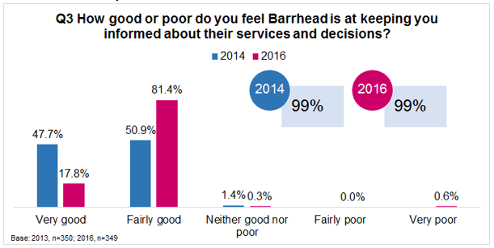

The Association have a proven track record of achieving high levels of satisfaction relating to how we keep tenants informed. Almost all our tenants questioned in both surveys were of the opinion that Barrhead Housing was very or fairly good at keeping tenants informed.

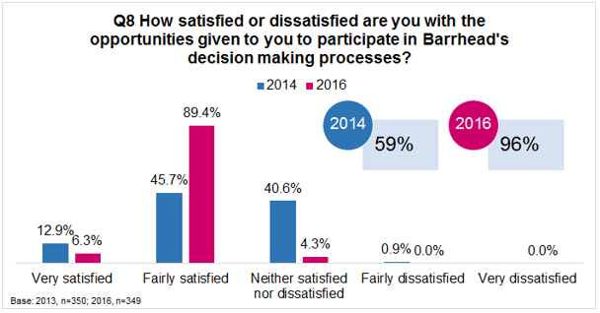

Furthermore, the percentage of tenants who were satisfied with the opportunities to participate had increased significantly from 59% in 2014 to 96% in 2016.

7.7 Repairs Satisfaction Surveys
Due to reduced levels of satisfaction as outlined within our 2016 survey, the
Association commissioned an independent survey and undertook over 360 individual surveys.

This independent survey ascertained that overall satisfaction with our repairs service sat at 93% and this process also provided us with valuable feedback from residents about our repairs service.

To maximise participation and feedback, the Association are now undertaking a monthly prize draw and we are continuing to see an increase in the number of surveys returned.

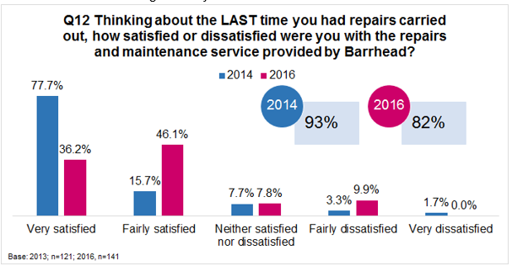

7.8 FLAIR Academy
We are members of FLAIR which is a grouping of housing associations
operating in Renfrewshire and East Renfrewshire.

FLAIR have developed a free training programme which is open to any
member of the public to which includes: team working in meetings; analysing real business information; taking part in real time decision making; learning about Social Policy with other local people.

The ultimate aim of the Academy is to develop these transferable skills and hopefully have a range of fully trained participants who will join our governing board and bring ideas, opinions and input.

7.9 Registered Tenant Organisations (RTO)
Barrhead Housing Association must keep a register of such tenant organisations, which is open to inspection by the public at any time. Groups can appeal to the Scottish Government if they are refused registration.

RTO status gives groups the statutory right to be provided with information and consulted about important decisions relating to our housing services.

To be registered, Barrhead Housing Association requires that any tenants’ group adopts a formal constitution, works in a fair, open and democratic manner and does not discriminate. The Association also requires the tenants’ group to keep tenants and other residents informed of its work on a regular basis.

Barrhead Housing Association must consult with RTOs before making or changing any policies, which include our Tenant Participation Strategy, which will have a significant impact on members of the group. Following any consultation Barrhead Housing Association must also demonstrate that it has taken account of any comments made by RTOs.
There are currently 3 Registered Tenant Organisations (RTOs) operating and serviced by East Renfrewshire area, being:
GROUP NAME | AREA OF OPERATION
Sheltered Housing in East Renfrewshire | Group covers all of East Renfrewshire Sheltered Housing
Auchenback Tenants and Residents  Association | Covers area of Auchenback
Thornliebank and Giffnock Tenants and  Residents Association | Group covers the Thornlibank and Giffnock
There is also a former RTO – Mearns Village Interested tenants where consultation continues but on a less formal basis.
These network are not strongly supported by tenants locally, where residents in our areas of operation prefer less formal methods of participation.

7.10 Other Information
In addition, we have:
- Continued to develop our user-friendly web-site exploring ways to make it more interactive for customers.
- Made financial provision for a tenant app/portal and will look at appropriate market software available in the coming months.
- Updated our website to ensure we will be ready for Freedom of Information and have developed an action plan to ensure all necessary information contained within our website complies with the Publication Scheme requirements.
- Have significantly increased our use of social media- Facebook and Twitter- to communicate with tenants.
- Produced 4 regular newsletters each year.
- Developed Readiness for Universal Credit (UC) information leaflets for current and prospective customers and ensured our website has relevant information for UC claimants
- Informed our tenants of all up and coming Social Security Scotland benefits which impact on them which may ultimately influence their decision on a range of matters.
- Continued to develop and improved newsletters with regular emphasise of articles to ensure tenants and customers are kept fully informed and have opportunities to participate locally.
- Issued an annual performance report and Value for Money Statement.
- Updated our Tenants Handbook to provide clearer information on things that tenants have told us matter to them, such as bin uplift days.
- Captured the communication methods of all our tenants and prospective tenants and are currently developing an action plan to roll this out in a range of operational functions i.e. emailing newsletters.
- Undertook consultation on a range of major housing issues including reviewing the Rent Arrears Policy, Estate Management Policy, Void Management Policy, Repairs Policy and Rent Policy.
- Ongoing use of quality satisfaction surveys for repairs carried out with an incentive to return surveys and allow the effective monitoring of our repairs service.
- Undertaken mystery shopping, involving Board Members and Scrutiny Panel Members from respective FLAIR Housing Associations;
- Continued use and promoting of a range of internal and external agencies/activities via the Barrhead Housing Association Television
- Extensively consulted tenants, residents and the Scrutiny Panel as part of the development of our Annual Performance Report; and
- Continued to participate in RTO-led estate management inspections as required.

8. Participation Standards
This section summarises the standards of service that customers can expect from us. We will:
- Provide support and information on setting up and running a tenants and residents group, including attending meetings when requested and appropriate;
- Provide information, support and advice on housing related issues to individual tenants and tenants groups;
- Provide information, support and advice to the Tenant Scrutiny Panel Members.
- Ensure we provide information in an easy to understand way and in accessible formats;
- Facilitate and arrange training and development events to meet the joint needs of tenants/customers and staff;
- Maintain a register of tenants groups and provide advice and support to groups on achieving registration status;
- Recognise the autonomy of tenants groups;
- Ensure tenants have access to agenda setting and adequate time is given for participation and consultation to take place;
- Consult with tenants to further develop standards in relation to tenant participation such as local newsletters, tenant conferences and policy reviews;
- Provide feedback to tenants following consultation exercises;
- Ensure that groups have the opportunity to influence the review of Association services with adequate time to respond;
- Ensure that the Association has attempted to overcome any barriers to customers being involved e.g.: using accessible venues, arranging meetings/events at times that suit tenants, providing assistance with travel and childcare, providing information in a range of formats and ensuring venues have disabled access.

9. Communication Strategy
The Association recognises that tenants and residents groups require access to accurate information if they are to participate fully in the decision making process.
Information will be provided by the Association to meet customers’ needs. This will allow customers to reach an informed view on the issues, and be involved in decision making.

Our Group communication Strategy has been developed to ensure that all internal and external communication and feedback is effective, meaningful and relevant and which provides a successful mechanism for two way communication.

Our Strategy sets out the ways in which we will communicate, participate and feedback to our customers. It identifies the standards and methods we will use to provide information, the types of information we will provide, the means of participation and how we will provide feedback.
The Association recognises that good communication and feedback is the responsibility of all staff.
Information will:
- Be expressed clearly, using plain English and avoiding jargon or providing explanations of any necessary jargon used in our communications;
- Be made available in a range of formats, including large print, Braille, alternative languages.
- Be of good quality, timely and relevant to tenants’ needs.
10. Participation and Consultation
To make sure that participation and consultation is maximised a range of methods will continue to be used. This will offer choice to customers and assist them to participate at a time, level and in a form that suits them best. This will also allow flexibility and local circumstance to be taken into account.
The Association will employ a range of methods to notify customers, and tenants and residents groups of issues that affect them and to provide feedback. Effective means of information, consultation and participation could include:
- Supporting the continued development of a tenant led Scrutiny Panel to help improve services.
- Supporting and attending events to help us engage with customers and residents.
- Undertaking roadshows if there is a demand for this.
- Consider undertaking an annual conference for tenants and other stakeholders.
- Providing funding and development support for tenants and residents groups.
- Providing briefing sessions.
- Enabling involvement in service reviews.
- Attending conferences.
- Undertaking surveys and questionnaires.
- Continuing to support tenant/customer led estate management walkabouts.
- Publishing information through newsletters, website, BHTV, local and national media.
- Consulting on draft future plans and strategies.
- Enhancing our consultation database of interested tenants.
- Undertaking focus groups.
- Providing representation at tenants and residents' meetings if required.
- Facilitating tenant participation and consultation with external services and service providers.
- Undertaking joint training with tenants/customers and staff.
- Providing access to a Tenants Handbook where all new tenants and tenants’ groups receive detailed information on a range of housing issues.
- Providing written information where tenants and RTOs will be notified in writing of major issues such as major repairs programmes or proposed changes to policies.
11 Action Plan
This section summarises the main actions we intend to undertake to develop participation and deliver the aims and objectives of the strategy and those as contained within our comprehensive 5 year Business Plan Strategic Objective Action Plan.
A full list of our Actions are contained within Appendix 1, where some of our main actions will include:
- Continued support, review effectiveness and development of the Customer-led Scrutiny Panel to help improve services and expand membership.
- Exploring the possibility with our FLAIR RSL partners for tenant led inspections to ensure continuous improvements across FLAIR organisations.
- Identify software which enhances our customer experience and enables them to engage with us in a variety of ways
- Consider the types of information required to recognise the needs of our tenants to maximise participation and communicate in a way to ensure they are treated fairly and with respect
- Review the questions within our imminent Satisfaction Survey to seek views on how we communicate and engage with tenants
- Work with various agencies across our communities to reduce social isolation
- Look at external funding opportunities to maximise tenant engagement
- Developing a rolling programme of training which meets the needs of customers and staff and look at Customer Service Accreditation.
- Developing an annual consultation and review programme in partnership with customers that sets out on what, when and how consultation and service review will take place on issues such as service reviews, rent and budget setting, and capital programme works.
- Agreeing at a local level action plans for all areas to promote and develop participation, with clear timescales.
- Undertaking other forms of consultation such as discussion groups.
- Developing joint working with external services and Registered Social Landlords
- Reviewing the resources available to support tenant participation.

12. Monitoring of the Strategy
The Participation Strategy will be a working document subject to continuous review to make sure that it is meeting objectives and achieving targets.
A range of methods will be used to monitor the strategy, these will include:
- The Tenant Scrutiny Panel will monitor the implementation and effectiveness of the strategy on an ongoing basis. Progress on implementing and monitoring the strategy will be reviewed annually and reported to the Association’s Governing Board.
The Annual Strategy Review will consider a range of information and feedback options exploring:
- Scottish Social Housing Charter Indicators and outcomes.
- How participation took place (i.e. what methods of participation were used; what and how were the issues/topics identified)?
- What arrangements were made to encourage participation and maximise accessibility?
- How were customers' views represented in the outcome of any participation exercise?
- How were the results of participation fed back to participants?
- What timescales were allowed for effective participation to take place?
- The cost of developing effective participation.
- Did customers receive adequate information, support and resources to allow them to participate effectively?
- How satisfied are tenants/customers with the participation process and the range of opportunities available to them? How would tenants like the process to be improved?
- Whether customers had the opportunity to become involved regardless of age, ethnic background, language, sexual orientation, particular needs or location?

13. Equality & Diversity
Barrhead Housing Association is firmly committed to providing fair and equal treatment to all our customers.

The Association will not discriminate against anyone on the grounds of race, social origin, disability, religion or belief, age, sexual orientation, marital status/civil partnerships, gender, gender re-assignment; pregnancy or maternity or other personal attributes.

We will make this policy available in alternative formats such as large print or Braille on request. Translation services for other languages will also be made available if you require this.

14. Strategy Review

The Governing Board will review the Strategy at least every three years. However, improvements in performance and service delivery may be made on a regular basis to reflect change and in light of various factors such as:

- New or revised legislation;
- Changes to the Regulatory Framework;
- Changes in good practice;
- Organisational change, e.g. revision of operational practices;
- Views of tenants and other service users;
- Auditing practices; and
- Resource requirements.

APPENDIX 1 TENANT PARTICIPATION 5 YEAR ACTION PLAN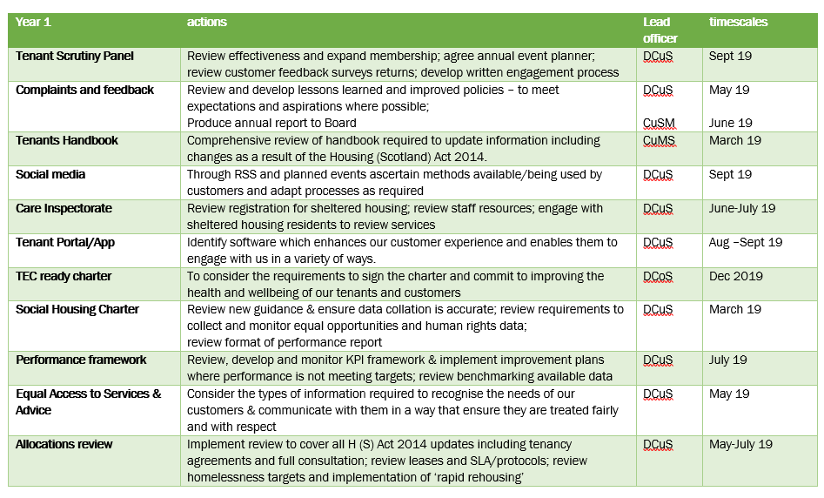
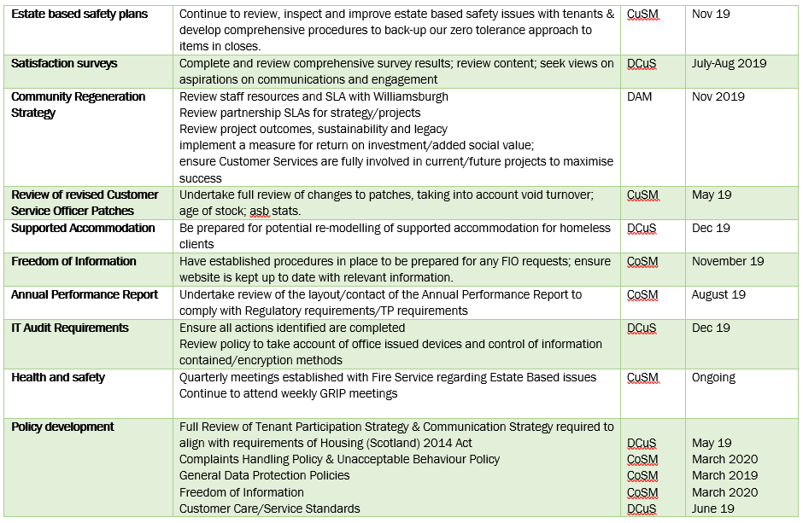

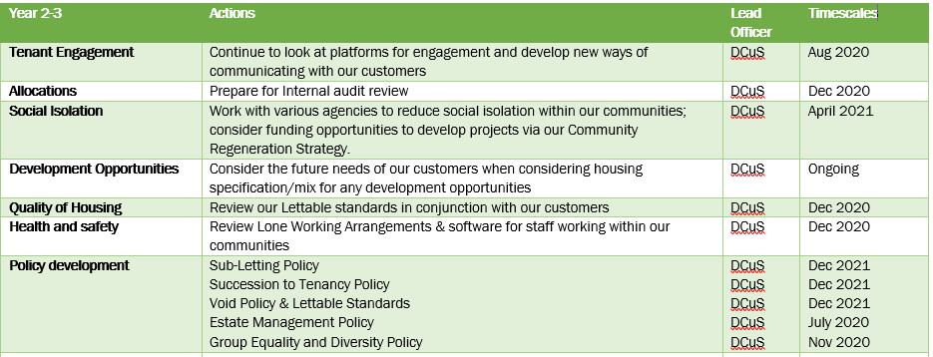

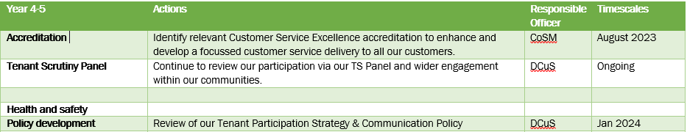

Key to Abbreviations
DCuS Director of Customer Services
CoSM Corporate Services Manager
CuSM Customer Services Manager
DAM Director of Asset Management

