For Office use only:
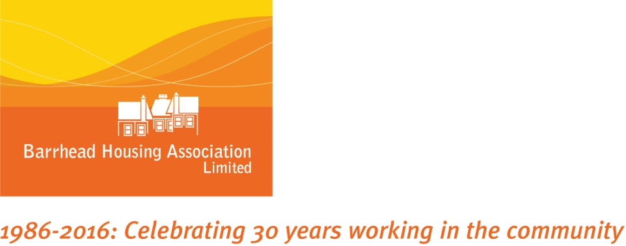

IN CONFIDENCE

PLEASE COMPLETE ALL SECTIONS

NAME:

POST APPLIED FOR: MODERN APPRENTICE IN HOUSING

The information that you supply in this application form will enable the interview panel to decide whether to invite you to an interview.

Whilst all sections may not be relevant to you personally, you should complete the form as fully and as accurately as possible to enable your application to be given full consideration.

CV will not be considered. When completed this form, along with an equal opportunities monitoring form, should be returned to:

Iain MacLean
Barrhead Housing Association Ltd
60-70 Main Street
Barrhead
G78 1SB

Or by e-mail to: enquiries@barrheadha.org

(If returning the application form by e-mail, please note that there is no need to also post a hard copy. If shortlisted you will be asked to sign your application form at a later stage.)

Closing date for receipt of applications is midnight Sunday 15 March 2020

Applications received after this time will NOT be considered

Barrhead Housing Association is a Disability Confident Employer and offers an interview to disabled people who meet the minimum criteria for the job.

The information provided within your application form
will be processed in accordance with the Data Protection Act 1998 and the General Data Protection Regulation (EU) 2016 (the GDPR).Unless successful, all employment applications will be retained for 12 months and then destroyed.

This page will not be shown to the short-listing panel.
For Office use only:

Personal Information
Title: Surname: First Name:

Address for Correspondence:

Postcode:

Private Telephone Number: Mobile Number:

E-mail Address:

Your Daytime Telephone Number (on which a message may be left):

Referees
Please give details of two referees. They should be qualified to comment on your ability and experience for this appointment and should include a referee from your current or most recent employer. Barrhead Housing Association does not accept references from family members.

References will only be requested after interviews have taken place.
Name:  Job title:  Company:  Address:  Postcode:  Email:  Tel No:  Fax No: | Name:  Job title:  Company:  Address:  Postcode:  Email:  Tel No:  Fax No:
Post Applied For: PROPERTY SERVICES TECHNICAL OFFICER
For Office use only:

Secondary Education (please list subjects passed)
Standard/’O’Grade  or equivalent | Grade | Higher Grade  or Equivalent | Grade

Further Education
University or Further Education Establishment | Course(s) &  Subjects Studied | Degrees, Diplomas, Certificates Obtained

Professional Qualifications
Name of Awarding Body | Qualifications Obtained, Membership of Professional Institution etc

Training Courses

(Please give details of any relevant short courses or training undertaken)
Course(s) Undertaken | Provider(s)

Computer Skills (please detail your experience)

Present or Most Recent Employment, if applicable
Name & Address of  Employer | Date From: |  |  | Date To:
 | Position Held:
 | Salary and other benefits/payments
 | Notice Required:
 | Reason For Leaving:
Nature of Post (describe your main duties):

Employment History (list in order of most recent first)
Name & Address of  Previous Employer(s) | From  Month/Year | To  Month/Year | Position Held, Main Duties and Reason for Leaving
Please continue on a separate sheet if necessary.

Employment with Barrhead Housing Association
Barrhead Housing Association wishes to compare your experience, skills and knowledge with its requirements for the post you are applying for. You should therefore, try to show in the following part of the form how you satisfy these giving specific examples. This does not have to be from paid work, but can be from other experience. The Selection Panel may consider candidates, who do not meet all the requirements, therefore please complete all sections as appropriate.

Essential
Good Literacy and Numeracy Skills
Interest in working in Social Housing
Ability to meet the Association’s Core Values
Good IT Skills
Self-motivated, Energetic and Enthusiastic
Understands how our behaviour can be interpreted and considers the impact we have on others
Is open and honest in workplace communications
Seeks and uses feedback to develop self and best practice
Seeks out and shares learning from and with colleagues, customers, partners and contractors

Additional Information
Please provide any relevant information not covered elsewhere on this form, which may include other activities e.g. voluntary work, major achievements, projects to date and indicate how this will enable you to contribute further to this post.

Disability
We are a Disability Confident Employer and are committed to the employment and career development of disabled people. To demonstrate our commitment we guarantee an interview to anyone with a disability whose application meets the minimum essential criteria for the post at the short-listing stage. The Equality Act 2010 defines a disabled person as someone who has a physical or mental impairment, which has a substantial and adverse long-term effect on his or her ability to carry out normal day-to-day activities.

□ Tick this box if you consider yourself disabled as defined by the Equality Act 2010.
False declarations will subsequently invalidate any contract of employment.

Relationship to Staff Members
If you are related to any employee of Barrhead Housing Association or anyone who has been employed as a staff member or has been engaged as a supplier, consultant or contractor in the last 12 months, please provide details:

Relationship to Governing Board Members
If you are related to a Board member of Housing Association or anyone who has been a Board member in the last 12 months, please provide details:

Rehabilitation of Offenders Act 1974
The Rehabilitation of Offenders Act 1974 enables some criminal convictions to become spent or ignored, after a ‘rehabilitation period’. Excepted posts are those to which the Rehabilitation of Offenders Act 1974 (Exceptions) Order 1975 applies. You may be entitled to withhold information about convictions that are ‘spent’ under the provision of the act. In the event of employment, any failure to disclose could result in dismissal or disciplinary action by your employer. If selected for interview you will be required to complete a criminal convictions declaration form that will only be reviewed if an offer of employment is being made.

Canvassing
Canvassing directly or indirectly in connection with the appointment shall disqualify your application. If discovered after appointment you will be liable to dismissal.

Entitlement to Work in UK
The Immigration, Asylum and Nationality Act 2006 makes it an offence to employ anyone who is not entitled to live or work in the EU. All applicants selected for interview will be required to provide evidence that they are entitled to live and work in the EU. Appropriate documentation may include the original of your current passport, visa, birth certificate or any other document (or combination of documents) indicated by the Act.

Do you currently have the right to live and work in the European Union Yes / No please delete as appropriate)

Confirmation of Qualifications
If selected for interview you will be required to bring with you the original certificate(s) of all qualifications referred to in this application. This extends to membership of professional bodies.

Advertisement Source

Where did you see this post advertised? ___________________________________

Declaration
I have read the guidance above and I declare that the information I have given in support of my application is, to the best of my knowledge and belief, true and complete. I understand that if it is subsequently discovered that any statement is false or misleading, or that I have withheld any relevant information my application may be disqualified or, if I have already been appointed, I may be dismissed without notice.

Signed: Date: __________________

