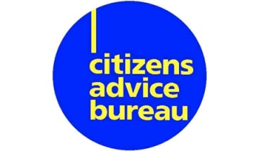
East Renfrewshire Citizens Advice Bureau had to shut its doors on Wednesday 18th March 2020 in response to the spread of COVID-19 but we are still available to support local residents in dealing with these troublesome times.

Worries about housing, benefits, debt or other household issues ??
Need advice to help you navigate your way through these exceptional times ??
Or just need confirmation you’re doing the right thing ??
Our Team are now working from home, with advice available by phone at the numbers outlined below, Monday – Friday, 9.30am – 3.00pm, or as specified.

HOUSING : Angela 07395941203
DEBT: Julie 07901607309
(MON, TUES, WED & THURS ONLY)
BENEFITS :
Anne 07340614626
(WED, THURS & FRI ONLY)
Aileen 07395935914
(MON, TUES, WED & THURS ONLY)

ARMED SERVICES ADVICE PROJECT / BENEFITS :
Rosie 07471005334
Mark Oswald 07562558670
HERO (HELPING EAST RENFREWSHIRE ONLINE)/ BENEFITS :
Ainsley 07594156780
UNIVERSAL CREDIT :
John 07388628543
Mark Richmond 07552466506
Helen 07395965393

EU SUPPORT ADVISER :
Cara 07500972862

NHS PATIENT ADVICE AND SUPPORT :
Maureen 07922496861
MONEY TALKS / GENERAL ENQUIRIES :
Mark Parsons 07539378806

For general or employment related enquiries please contact ANY
of the above numbers.

